SOFT8026 - Data-driven Microservices
Assignment 2 Form

Instructions
Please complete the following form and include in the zip file you submit. Include screenshots / images in the appendices below the form.

Move to Kubernetes
Describe the progress you made moving your app to Kubernetes | I followed the same steps as discussed in class. All the microservices are moved to kubernetes, the list of them below,  1. vgsales_server: Same from assignment 1  2. vgreview_server: Created for new dataset  3. vgsales_weblog: Same as assignment 1 except a few changes.  4. vgsales_client: Same as assignment 1  5. vgreview_client: Created for new dataset
Describe what additional functionality you added, e.g. 2nd data source; include decisions made around architecture to include the extra functionality. | To accommodate the new dataset, I created different application pods and two new repositories. They are below,  1. vgreview_client: Responsible to read the dataset and send 2 records per second  2. vgreview_server: Responsible for finding the game with the highest number of user ratings. The second dataset consists of game titles, game info and user reviews.
Describe your scaling and update strategy (as implemented in your Kubernetes deployments) – e.g. include why you chose to scale in the ratio among microservices that you did | I scaled the application horizontally. The application scaling and update strategy is defined in the yml file. I choose to keep the replica set for all the deployments to 1. The decision was made considering the hardware resources constraints. The application in real world would be scaled with various replica set values. If I had the resources needed for scaling, I would assign higher replica sets to weblog and server deployments.
Testing
Briefly describe the test you created and what type of test it is? | Unit test using unittest package in python is used to ensure application is working as expected. An endpoint was created to view and verify the metrics computed by the server.
Why did you choose that test? | I choose the test to see if the application is working properly and providing expected response without needing to open or debug the application.
How did or how would you automate the test? | The test is automated by using postman and getting requests from the weblog server. The request is made by postman to the weblog server and the server returns a json response containing the metric keys and values.
Monitoring
Briefly describe the monitor you created and what type of monitor it is? | The monitor is created using Prometheus and Grafana. Prometheus is responsible for collecting metrics related to kubernetes services and grafana pulls these metrics to create visualization of the data. Helm was used to install Prometheus and Grafana on k3s. The monitoring consists of cluster resource usage and systems processes and memory usage. I tried to add some visualization for pods but there was no data visualized and because of time constraints, I opted it out.
Why did you choose that monitor? | This monitor was chosen as its widely popular amongst the free source community as it is able to offer a wide range of metrics and visualisations, which would perfectly suit this application.
Serverless Function
What serverless function and functionality did you implement? | The dataset used in 1st assignment (vgsales.csv) consisted of game sales in most selling continents. There is also a predefined column in the dataset which has total global sales in all continents. During assignment 1, I realised these values were inconsistent and weren’t reliable. Hence, for assignment 1, I calculated the total sales manually by adding sales in all regions instead of using the predefined column.  The serverless function is responsible to check if the addition of game sales in all regions in the dataset is equal to the total sales in the dataset. If yes, the function returns true otherwise returns false. The function will be passed with each row as an input.
Where in your application did you or would you slot in this functionality? | The application will use a serverless function to check if the total sales is correct, if yes the application will save time and avoid computing addition. If the sales are incorrect, the application will compute the addition in all regions.
Any other comments?
(e.g. you may have had to opt for Plan B, using Compose to implement extra functionality)

Apologies for the late submission. In order to get serverless functions to run on my system, I had to downgrade the kubectl version from v1.23.6+k3s1 to v1.17.2+k3s1, which put me into a lot of trouble. This is because before downgrading part 1 deployments were working fine and they stopped working after downgrading. I am attaching a screenshot of the same below

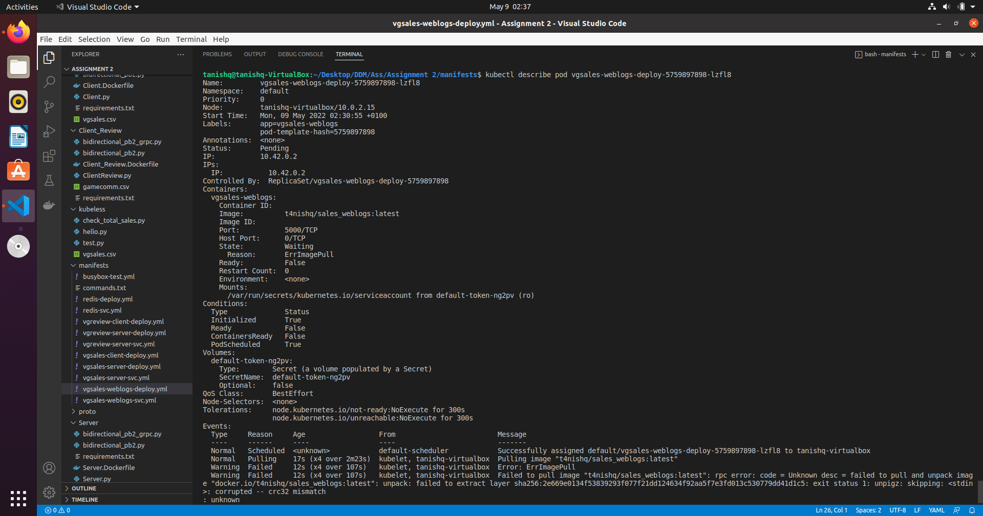
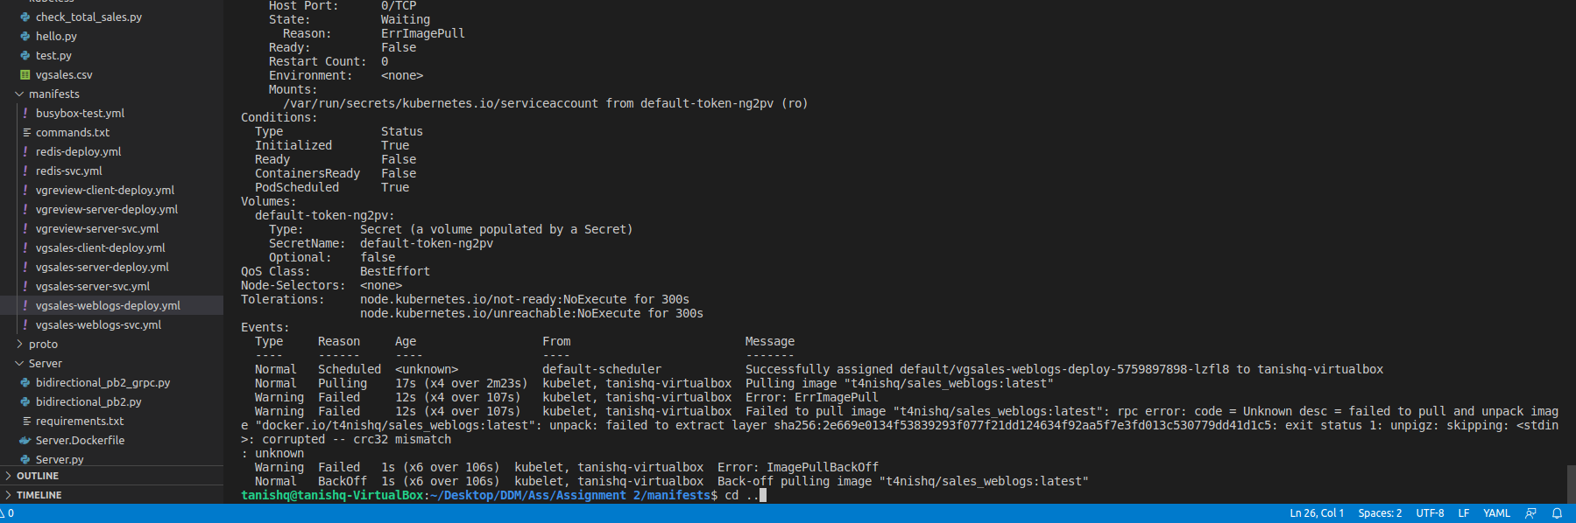

I was able to fix it after upgrading the kubectl. Unfortunately it took me a while before identifying the issue, hence the delay.

Appendix A – Screenshot(s) of your application running (e.g. Kubernetes log output, any web pages, etc.)

Please note: The left table shows the metrics computed in assignment 1 and the right table shows the metrics computed in assignment 2.
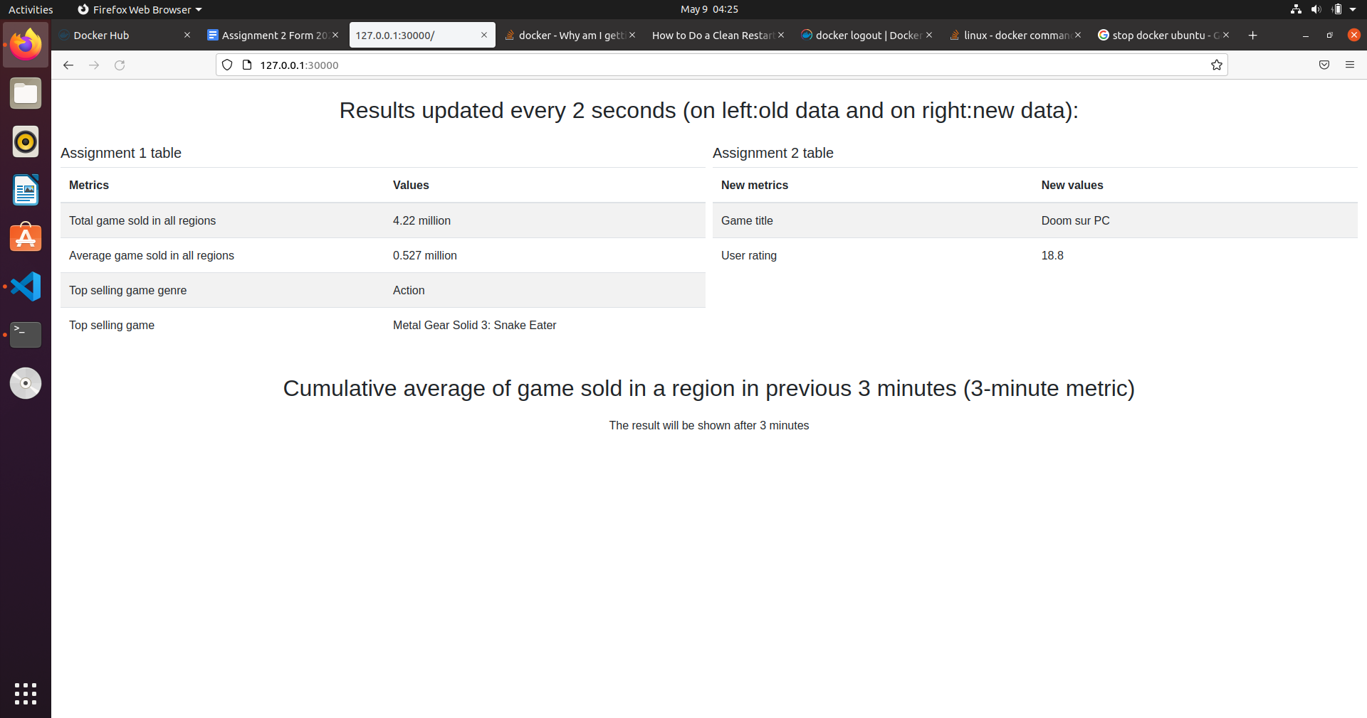

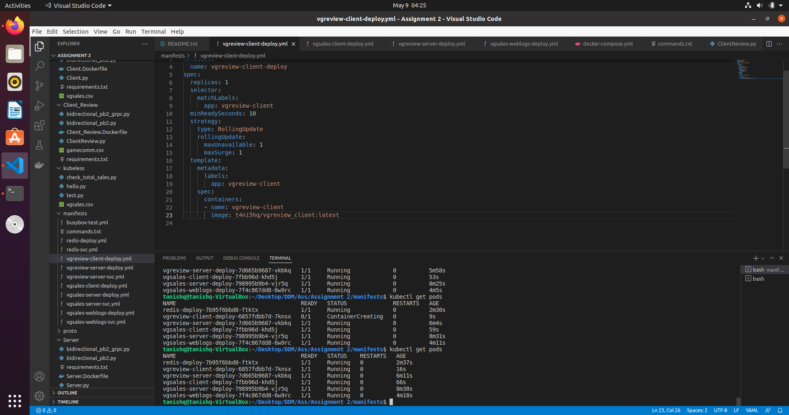

Appendix B – Screenshot(s) of your application being tested

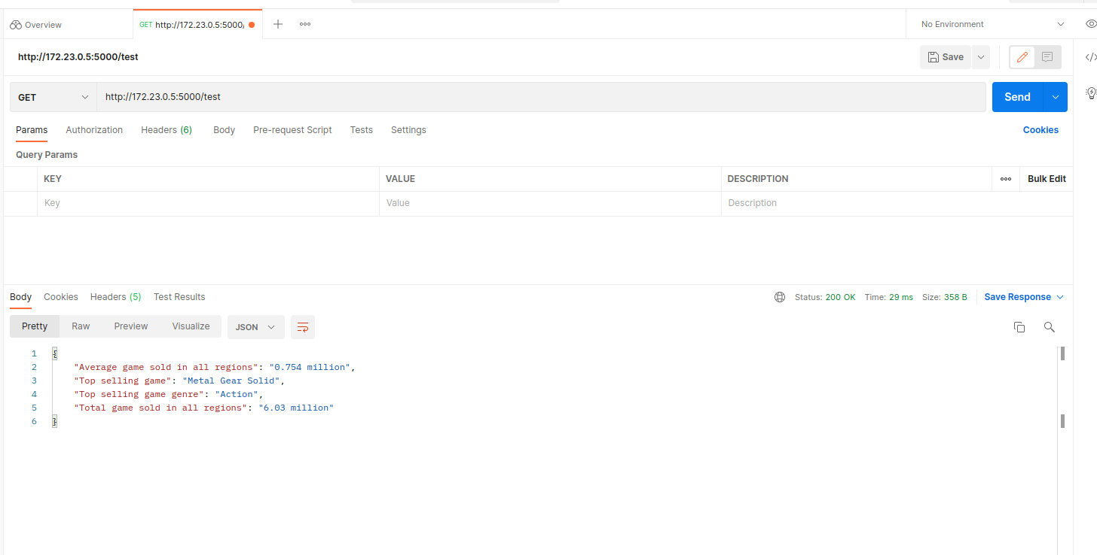

Appendix C – Screenshot(s) of your application being monitored

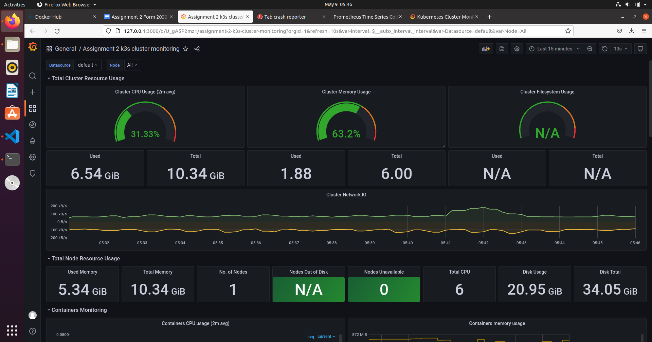

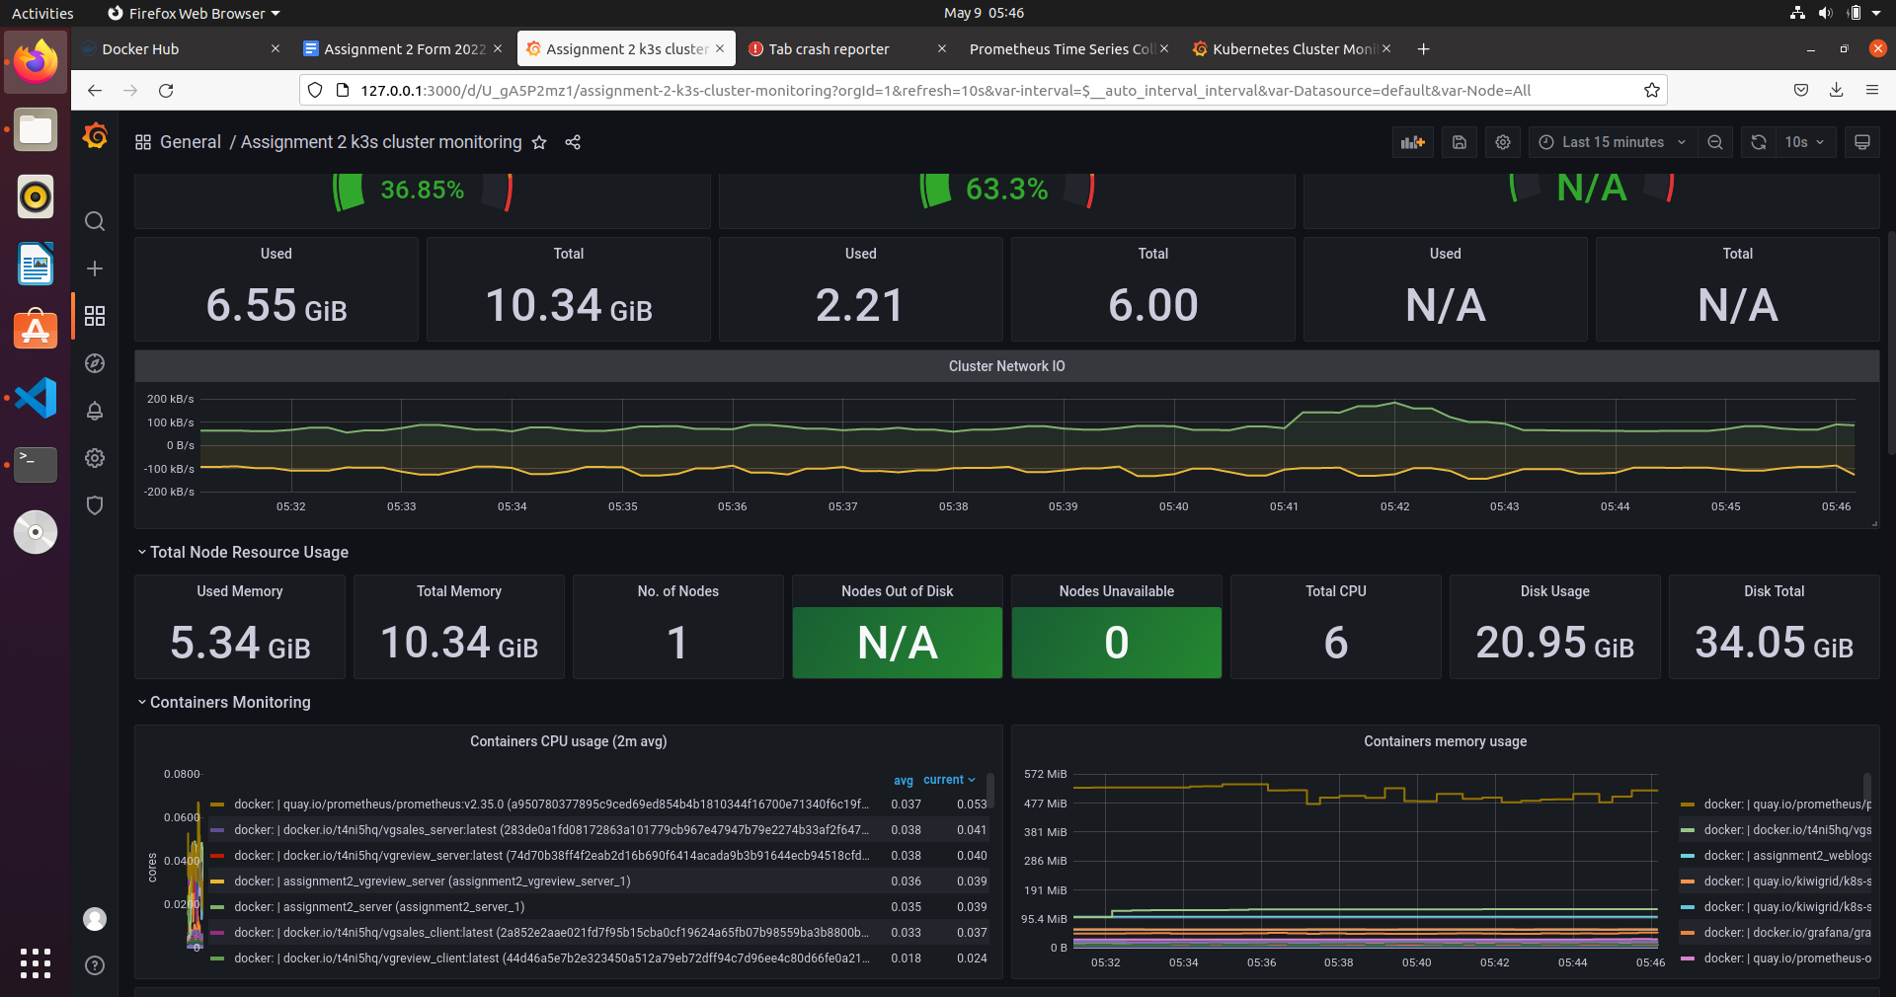

Appendix D – Screenshot(s) of your serverless function running

